Questions:
- What Is Bagging in Machine Learning?
- What Is Bootstrapping?
- What are the advantages of Bagging in Machine Learning?
- What are the disadvantages of Bagging in Machine Learning?
- If your dataset is suffering from high variance, how would you handle it?
- Differentiate between Boosting and Bagging?
- How does Bagging reduces variance?
- How Bagging Classifier works?
- How Bagging Regressor works?
- What is Pasting and Stacking?

Answers:
- What Is Bagging in Machine Learning?
Bagging, also known as Bootstrap aggregating, is an ensemble learning technique that helps to improve the performance and accuracy of machine learning algorithms. It is used to deal with bias-variance trade-offs and reduces the variance of a prediction model. Bagging avoids overfitting of data and is used for both regression and classification models, specifically for decision tree algorithms.
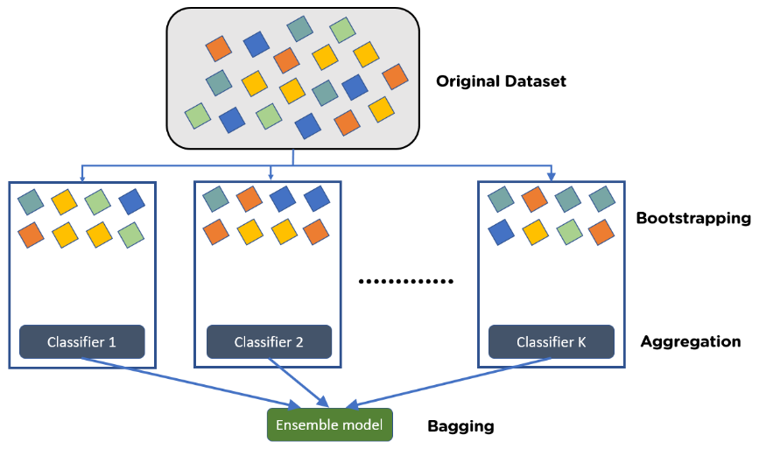

What is Bootstrapping?
Bootstrapping is the method of randomly creating samples of data out of a population with replacement to estimate a population parameter.
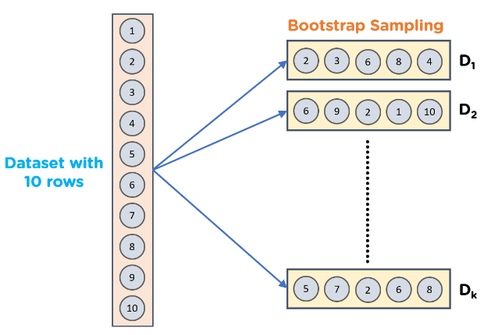

3. What are the advantages of Bagging in Machine Learning?
- It deals with higher dimensional data efficiently
- The biggest advantage of bagging is that multiple weak learners can work better than a single strong learner.
- It provides stability and increases the machine learning algorithm’s accuracy that is used in statistical classification and regression.
- Bagging helps in reducing variance. Hence minimizes the overfitting of data

4. What are the disadvantages of Bagging in Machine Learning?
- It may result in high bias if it is not modelled properly and thus may result in underfitting.
- Since we must use multiple models, it becomes computationally expensive and may not be suitable in various use cases.

5. If your dataset is suffering from high variance, how would you handle it?
For datasets with high variance, we could use the bagging algorithm to handle it. Bagging algorithm splits the data into subgroups with sampling replicated from random data. After the data is split, random data is used to create rules using a training algorithm. Then we use polling technique to combine all the predicted outcomes of the model.

6. Differentiate between Boosting and Bagging?
Bagging and Boosting are variants of Ensemble Techniques.
Bootstrap Aggregation or bagging is a method that is used to reduce the variance for algorithms having very high variance. Decision trees are a particular family of classifiers which are susceptible to having high bias.
Decision trees have a lot of sensitiveness to the type of data they are trained on. Hence generalization of results is often much more complex to achieve in them despite very high fine-tuning. The results vary greatly if the training data is changed in decision trees.
Hence bagging is utilised where multiple decision trees are made which are trained on samples of the original data and the final result is the average of all these individual models.
Boosting is the process of using an n-weak classifier system for prediction such that every weak classifier compensates for the weaknesses of its classifiers. By weak classifier, we imply a classifier which performs poorly on a given data set.
It’s evident that boosting is not an algorithm rather it’s a process. Weak classifiers used are generally logistic regression, shallow decision trees etc.
There are many algorithms which make use of boosting processes but two of them are mainly used: Adaboost and Gradient Boosting and XGBoost.

7. How does Bagging reduces variance?
Bagging ensemble uses randomization of the dataset (will be discussed later in this article) to reduce the variance of base models keeping the bias low. The variance of base models is reduced by combining strategies of bootstrap sampling and aggregation.

8. How Bagging Classifier works?
A Bagging classifier is an ensemble meta-estimator that fits base classifiers each on random subsets of the original dataset and then aggregate their individual predictions (by voting) to form a final prediction.
Each base classifier is trained in parallel with a training set which is generated by randomly drawing, with replacement, N examples(or data) from the original training dataset – where N is the size of the original training set. Training set for each of the base classifiers is independent of each other. Many of the original data may be repeated in the resulting training set while others may be left out.
Bagging reduces overfitting (variance) by averaging or voting, however, this leads to an increase in bias, which is compensated by the reduction in variance though.

9. How Bagging Regressor works?
A Bagging classifier is an ensemble meta-estimator that fits base classifiers each on random subsets of the original dataset and then aggregate their individual predictions (by averaging) to form a final prediction. Predictions are made for regression problems by averaging the prediction across the decision trees.

10. What is Pasting and Stacking?
Bagging and pasting both involve training models using subsets of the training data, the only difference is whether sampling is done with replacement or without replacement.
- Bagging (as seen below, this is also called bootstrapping): training data sample is chosen using with replacement
- Pasting: training data sample is chosen using without replacement.
- Stacking considers heterogeneous weak learners, learns them in parallel and combines them by training a meta-model to output a prediction based on the different weak models’ predictions

